**STUDY QUESTIONS**

1. The following data represents the number of printer ribbons used annually in a

company by twenty-eight departments. This is an example of ______________ data.

8 4 5 10 6 5 4 6 3 4 4 6 1 12

2 11 2 5 3 2 6 7 6 12 7 1 8 9

1. Below is a frequency distribution of ages of managers with a large retail firm. This is

an example of _______________ data.

Age f

20-29 11

30-39 32

40-49 57

50-59 43

over 60 18

1. For best results, a frequency distribution should have between _____ and _____

classes.

4. The difference between the largest and smallest numbers is called the ____________.

5. Consider the values below. In constructing a frequency distribution, the beginning

Point of the lowest class should be at least as small as _____ and the endpoint of the

highest class should be at least as large as _____.

27 21 8 10 9 16 11 12 21 11 29 19 17 22 28 28 29 19 18 26 17 34 19

16 20

6. The class midpoint can be determined by _______________.

7-9 Examine the frequency distribution below:

class frequency

5-under 10 56

10-under 15 43

15-under 20 21

20-under 25 11

25-under 30 12

30-under 35 8

7. The relative frequency for the class 15-under 20 is _______________.

8. The cumulative frequency for the class 20-under 25 is _______________.

9. The midpoint for the class 25-under 30 is ___________.

10. The graphical depiction that is a type of vertical bar chart and is used to depict a

frequency distribution is a _______________.

11. The graphical depiction that utilizes cumulative frequencies is a _______________.

12. The graph shown below is an example of a _______________.

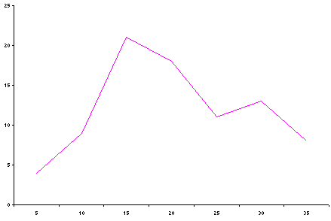

13. Consider the categories below and their relative amounts:

Category Amount

A 112

B 319

C 57

D 148

E 202

If you were to construct a Pie Chart to depict these categories, then you would allot

_______________ degrees to category D.

14. A graph that is especially useful for observing the overall shape of the distribution of

data points along with identifying data values or intervals for which there are

groupings and gaps in the data is called a ______________________.

15. Given the values below, construct a stem and leaf plot using two digits for the stem.

346 340 322 339 342 332 338

357 328 329 346 341 321 332

16. A vertical bar chart that displays the most common types of defects that occur with a

product, ranked in order from left to right, is called a ­­__________________.

17. A process that produces a two-dimensional table to display the frequency counts for two

variables simultaneously is called a ____________________.

18. A two-dimensional plot of pairs of points often used to examine the relationship of two

numerical variables is called a _________________.

**ANSWERS TO STUDY QUESTIONS**

1. Raw or Ungrouped 11. Ogive

2. Grouped 12. Frequency Polygon

3. 5, 15 13. 148/838 of 360o = 63.6o

4. Range 14. Dot Plot

5. 8, 34 15. 32 1 2 8 9

33 2 2 8 9

6. Averaging the two class endpoints 34 0 1 2 6 6

35 7

7. 21/151 = .1391

16. Pareto Chart

8. 131

17. Cross Tabulation

9. 27.5

18. Scatter Plot 10. Histogram